***OS - Operating System***

**Android:**

We has chosen android for because it is the most used OS in the world .

Android application makes people to access their library account in order to check availability of books in library by this way we can access library system through our mobile easily without using computers.

**Android History:**

* Android was founded in palo alto,California,in October 2003.
* Android was founded by andy rubin,rich miner,nick sears,chris white
* Googles decision to make Andriod an open source allowed it to become highly popular with third party phone makers.
* It was developed by a consortium of developers known as the open hand alliance.

**Android Version :**

* Android version 9.0 pie is used for application or any other lower versions can be used for the application.
* Android ‘s kernel is based on the linux kernal’s long-term support(LTS)branches.As of 2018,android targets versions 4.4,4.9 or 4.14 of the linux kernals.
* Linux kernel has further architectural changes that are implement by google such as ashmen,ION,out of memory (OOM)handling.

**Advantages of Andriod:**

* Since Android os is open source so, most of the leading handset makers in the world have Andriod phones.
* Universal charges.
* Availability of free apps in google play store.
* Great social networking integration.
* Using of apps and tools in android are easy to use.

**Number of users in the world:**

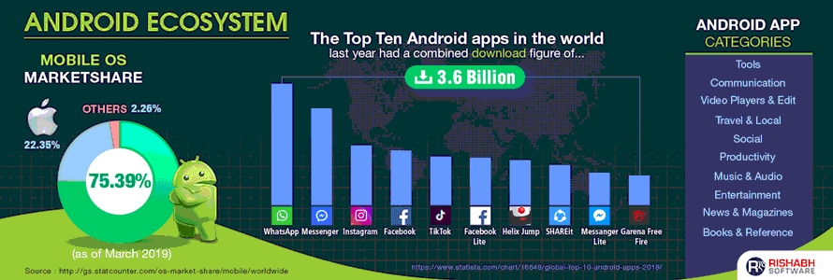

With over 86.8% share ,Android OS dominates the mobile app development market.

Google recently announced that there are 2.5 billion active android devices.

The number of users are growing quickly,its partners are also increasing .

**Type of application for library management:**

* It is Used to build a small public library,a class library.
* We can also manage our own wishlist.
* We can keep track of books that you lend to or borrow from frirnds and notify when a book is overdue.